ISO 20022

Cheques Management

Message Definition Report Part 1

Approved by the Payments SEG on 04 October 2021

This document provides information about the use of the messages for Cheques Management.

October 2021

Table of Contents

Table of Contents 3

1 Introduction 5

1.1 Terms and Definitions 5

1.2 Abbreviations and Acronyms 5

1.3 Document Scope and Objectives 5

1.4 References 6

2 Scope and Functionality 7

2.1 Background 7

2.2 Scope 7

2.3 Groups of Message Definitions and Functionality 7

3 BusinessRoles and Participants 8

3.1 Participants and BusinessRoles Definitions 8

3.2 BusinessRoles and Participants Table 9

4 BusinessProcess Description 10

5 Description of BusinessActivities 11

5.1 Cheque Presentment Notification 11

5.2 Cheque Cancellation or Stop 12

6 BusinessTransactions 13

6.1 Cheque Presentment Notification 13

6.2 Cheque Cancellation 13

6.3 Cheque Stop 14

7 Business Examples 15

7.1 ChequePresentmentNotification camt.107.001 15

7.2 ChequeCancellationOrStopRequest camt.108.001 16

7.3 ChequeCancellationOrStopReport camt.109.001 17

8 Revision Record 19

Preliminary Note

The Message Definition Report (MDR) is made of three parts:

MDR Part 1

This describes the contextual background required to understand the functionality of the proposed message set. Part 1 is produced by the submitting organisation that developed or maintained the message set in line with an MDR Part 1 template provided by the ISO 20022 Registration Authority (RA) on [www.iso20022.org](http://www.iso20022.org).

MDR Part 2

This is the detailed description of each message definition of the message set. Part 2 is produced by the RA using the model developed by the submitting organisation.

MDR Part 3

This is an extract if the ISO 20022 Business Model describing the business concepts used in the message set. Part 2 is an Excel document produced by the RA.

# Introduction

## Terms and Definitions

The following terms are reserved words defined in ISO 20022 Edition 2013 – Part1. When used in this document, the UpperCamelCase notation is followed.

| Term | Definition |
| --- | --- |
| BusinessRole | Functional role played by a business actor in a particular BusinessProcess or BusinessTransaction. |
| Participant | Involvement of a BusinessRole in a BusinessTransaction. |
| BusinessProcess | Definition of the business activities undertaken by BusinessRoles within a BusinessArea whereby each BusinessProcess fulfils one type of business activity and whereby a BusinessProcess may include and extend other BusinessProcesses. |
| BusinessTransaction | Particular solution that meets the communication requirements and the interaction requirements of a particular BusinessProcess and BusinessArea. |
| MessageDefinition | Formal description of the structure of a message instance. |

1. When a MessageDefinition or message identifier is specified, it should include the variant and version number. However, in this document (except in the business examples section, if present), variant and version numbers are not included. In order to know the correct variant and version number for a MessageDefinition, the related Message Definition Report Part 2 document should be consulted.

## Abbreviations and Acronyms

The following is a list of abbreviations and acronyms used in the document.

| Abbreviation/Acronyms | Definition |
| --- | --- |
| camt | ISO 20022 Cash Management business area |

## Document Scope and Objectives

This document is the first part of the Message Definition Report (MDR) that describes the BusinessTransactions and underlying message set. For the sake of completeness, the document may also describe BusinessActivities that are not in the scope of the business processes covered in this document.

This document describes the following:

* the BusinessProcess scope
* the BusinessRoles involved in these BusinessProcesses

The main objectives of this document are as follows:

* to provide information about the messages that support the business processes
* to explain the BusinessProcesses and BusinessActivities these messages have addressed
* to give a high level description of BusinessProcesses and the associated BusinessRoles
* to document the BusinessTransactions
* to provide business examples

The messages definitions are specified in Message Definition Report Part 2.

## References

| Document | Version | Date | Author |
| --- | --- | --- | --- |
| ISO20022BJ_SWIFT_ChequesCharges_v1.doc | 1.0 | 2020-07-03 | SWIFT |
|  |  |  |  |

# Scope and Functionality

## Background

This Message Definition Report covers a set of three message definitions developed by SWIFT in close collaboration with payments market infrastructure and cash service providers and approved by the Payments Standards Evaluation Group (SEG) on 4th October 2021. These messages are specifically designed to support cheque management.

## Scope

The cheque management messages facilitates the agents to present, stop and cancel cheques.



## Groups of Message Definitions and Functionality

1. These messages are to be used with the ISO 20022 Business Application Header (head.001). The schema and more information about the Business Application Header (BAH) can be found on the www.iso20022.org web site

### Groups

The messages in this message set cover cheque management.

#### Cheque Management

| MessageDefinition | Message Identifier |
| --- | --- |
| ChequePresentmentNotification | camt.107 |
| ChequeCancellationOrStopRequest | camt.108 |
| ChequeCancellationOrStopReport | camt.109 |

### Functionality

See Message Definition Report Part 2 for the message formats.

# BusinessRoles and Participants

A BusinessRole represents an entity (or a class of entities) of the real world, physical or legal, a person, a group of persons, a corporation. Examples of BusinessRoles: “Financial Institution”, “Automated Clearing House”, “Central Securities Depository”.

A Participant is a functional role performed by a BusinessRole in a particular BusinessProcess or BusinessTransaction. Examples of Participants: the “user” of a system, “debtor”, “creditor”, “investor”.

The relationship between BusinessRoles and Participants is many-to-many. One BusinessRole can be involved as different Participants at different moments in time or at the same time. Examples of BusinessRoles: "user", "debtor”, "creditor", "investor". Different BusinessRoles can be involved as the same Participant.

In the context of Cheque Management the high-level BusinessRoles and typical Participants can be represented as follows:

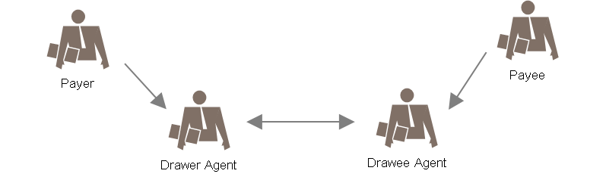

## Participants and BusinessRoles Definitions

Participants

| Description | Definition |
| --- | --- |
| Account Servicer | Agent, which can be a financial institution or a service provider, that provides account services.  Also named Account Servicing Institution |
| Account Owner | Party that legally owns the account with the account servicer. |

Business Roles

| Description | Definition |
| --- | --- |
| Payer | The party ordering the drawee agent to pay a specific amount, upon demand. |
| Payee | The party that receives an amount of money as specified in the cheque. |
| Drawer Agent | The agent servicing the account of the cheque payer. |
| Drawee Agent | The agent on which a cheque is drawn. |

## BusinessRoles and Participants Table

| BusinessRole | Participant  Account Servicer | Participant  Account Owner |
| --- | --- | --- |
| Drawer Agent | X |  |
| Drawee Agent | X |  |
| Payer |  | X |
| Payee |  | X |

# BusinessProcess Description

This diagram represents the high level BusinessProcesses.

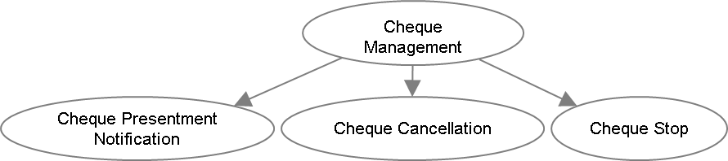

Cheque Presentment Notification

| Item | Description |
| --- | --- |
| Definition | The drawee agent advises, or confirms to an enquiring agent, the details concerning one or more cheques. |
| Trigger | Cheque payment |
| Pre-conditions | Cheque is presented. |
| Post-conditions | Successful cheque presentment |
| Role | Drawer agent, drawee agent |

Cheque Cancellation

| Item | Description |
| --- | --- |
| Definition | Drawer agent, or an agent acting on behalf of the drawer agent, requests the agent on which the cheque has been drawn (the drawee agent), to cancel the presentment of one or more cheques. |
| Trigger | Cancel the cheque |
| Pre-conditions | Cheque issuance and presentment notification |
| Post-conditions | Success or failure status of cancellation |
| Role | Drawer agent, drawee agent |

Cheque Stop

| Item | Description |
| --- | --- |
| Definition | Drawer agent, or an agent acting on behalf of the drawer agent, requests the agent on which the cheque has been drawn (the drawee agent), to stop the presentment of one or more cheques. |
| Trigger | Stop the cheque |
| Pre-conditions | Cheque issuance and presentment notification |
| Post-conditions | Success or failure status of stop |
| Role | Drawer agent, drawee agent |

# Description of BusinessActivities

This section presents the different BusinessActivities within each BusinessProcess. The BusinessActivities of a process are described with activity diagrams.

Legend

| Symbol | Name | Definition |
| --- | --- | --- |
|  | Start Point | Shows where the lifecycle of the business process commences. |
|  | End Point | Shows where the lifecycle of the business process may ends. |
|  | Lozenge (or diamond) | Indicates that a choice between several actions can be made. |
|  | Bar | Indicates that several actions are initiated in parallel. |

## Cheque Presentment Notification

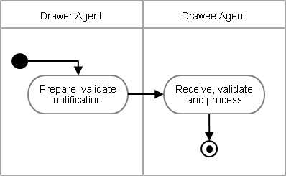

| Step | Description | Initiator |
| --- | --- | --- |
| Prepare, validate notification | The validated notification sent to the drawee agent. A single message may contain one or more transactions. | Drawer Agent |
| Receive, validate and process | The notification is received, validated and processed. | Drawee Agent |

## Cheque Cancellation or Stop

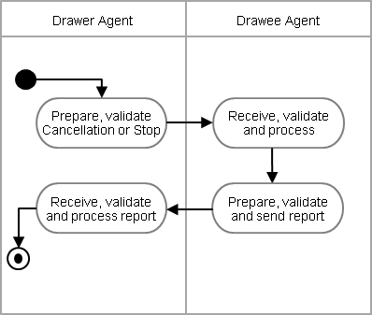

| Step | Description | Initiator |
| --- | --- | --- |
| Prepare, validate Cancellation or Stop | The validated cancellation or stop request message is sent to the drawee agent. | Drawer Agent |
| Receive, validate and process | The request is received, validated and processed. | Drawee Agent |
| Prepare, validate and send report | The status report is prepared with required information for the drawer agent. | Drawee Agent |
| Receive, validate and process report | The report is received, validated and reconciled with the request message. | Drawer Agent |

# BusinessTransactions

This section describes the message flows based on the activity diagrams documented above. It shows the typical exchanges of information in the context of a BusinessTransaction.

## Cheque Presentment Notification

The drawer agent sends a ChequePresentmentNotification message to the drawee agent. The ChequePresentmentNotification message informs the drawee agent about the cheque submission. A single notification message can provide details of one or more cheques. The notification message facilitates the drawee agent to follow up the cheque submission and relevant business process.

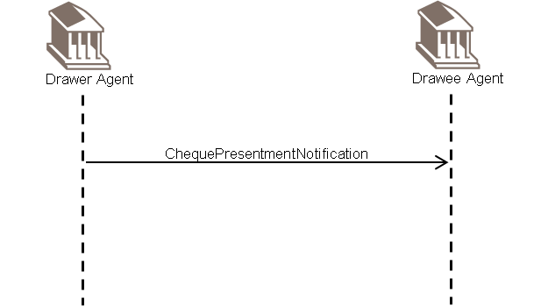

## Cheque Cancellation

The drawer agent sends a ChequeCancellationOrStopRequest message to the drawee agent to request the drawee agent to cancel a cheque. A relevant reason is provided. The drawee agent processes the request and sends a ChequeCancellationOrStopReport to the drawer agent.

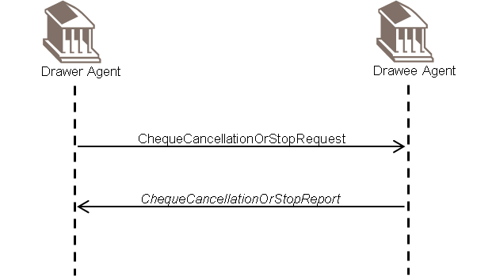

## Cheque Stop

The drawer agent sends a ChequeCancellationOrStopRequest message to the drawee agent to request the drawee agent to stop a cheque. A relevant reason is provided. The drawee agent processes the request and sends a ChequeCancellationOrStopReport to the drawer agent.



# Business Examples

This section describes business examples of the use of the various MessageDefinitions.

## ChequePresentmentNotification camt.107.001

Description

A ChequePresentmentNotification message is sent by a drawer bank to the drawee bank, to advise the drawee bank of one cheque.

Message Instance

|  |  |
| --- | --- |
| XML | Comment |
| <ChqPresntmntNtfctn> | Cheque Presentation Notification |
| <GrpHdr> | Group Header |
| <MsgId>00001</MsgId> | Message Identification |
| <CreDtTm>2021-01-14T09:30:00</CreDtTm> | Creation Date Time |
| <NbOfChqs>1</NbOfChqs> | Number Of Cheques |
| </GrpHdr> |  |
| <Chq> | Cheque (one repetition) |
| <InstrId>2021-34934739</InstrId> | Instruction Identification |
| <ChqNb>210092979</ChqNb> | Cheque Number |
| <IsseDt>2021-01-11</IsseDt> | Issue Date |
| <Amt Ccy="GBP">5000</Amt> | Amount of the check |
| <Pyer> | Payer |
| <Nm>Astra Pharma</Nm> |  |
| </Pyer> |  |
| <DrwrAgt> | Drawer Agent |
| <FinInstnId> |  |
| <BICFI>PEFIGB22</BICFI> |  |
| </FinInstnId> |  |
| </DrwrAgt> |  |
| <Pyee> | Payee |
| <Nm>Mortimer Associates</Nm> |  |
| </Pyee> |  |
| </Chq> |  |
| </ChqPresntmntNtfctn> |  |

## ChequeCancellationOrStopRequest camt.108.001

Description

A ChequeCancellationOrStopRequest message is sent by a drawer bank to the drawee bank to request to stop the payment of a cheque.

Message Instance

|  |  |
| --- | --- |
| XML | Comment |
| <ChqCxlOrStopReq> | Cheque Cancellation Or Stop Request |
| <GrpHdr> | Group Header |
| <MsgId>00049</MsgId> | Message Identification |
| <CreDtTm>2021-01-14T12:30:00</CreDtTm> | Creation Date Time |
| <NbOfChqs>1</NbOfChqs> | Number Of Cheques |
| </GrpHdr> |  |
| <Chq> |  |
| <InstrId>2021-34934844</InstrId> | Instruction Identification |
| <OrgnlInstrId>2021-34934739</OrgnlInstrId> | Original Instruction Identification |
| <ChqNb>210092979</ChqNb> | Cheque Number |
| <IsseDt>1957-08-13</IsseDt> | Issue Date |
| <Amt Ccy="GBP">5000</Amt> | Amount of the check |
| <DrwrAgt> | Drawer Agent |
| <FinInstnId> |  |
| <BICFI>PEFIGB22</BICFI> |  |
| </FinInstnId> |  |
| </DrwrAgt> |  |
| <Pyee> | Payee |
| <Nm>Mortimer Associates</Nm> |  |
| </Pyee> |  |
| <ChqCxlOrStopRsn> | Cheque Cancellation Or Stop Reason |
| <Rsn> |  |
| <Cd>LOST</Cd> | Cheque is lost |
| </Rsn> |  |
| </ChqCxlOrStopRsn> |  |
| </Chq> |  |
| </ChqCxlOrStopReq> |  |

## ChequeCancellationOrStopReport camt.109.001

Description

A ChequeCancellationOrStopReport message is sent by the drawee agent to the drawer agent to specify the actions taken in attempting to stop the payment of a cheque.

Message Instance

|  |  |
| --- | --- |
| XML | Comment |
| <ChqCxlOrStopRpt> | Cheque Cancellation Or Stop Report |
| <GrpHdr> | Group Header |
| <MsgId>CE9759884</MsgId> | Message Identification |
| <CreDtTm>2021-01-15T09:30:00</CreDtTm> | Creation Date Time |
| <NbOfChqs>1</NbOfChqs> | Number Of Cheques |
| </GrpHdr> |  |
| <Chq> |  |
| <InstrId>2021-34934844</InstrId> | Instruction Identification |
| <OrgnlInstrId>2021-34934739</OrgnlInstrId> | Original Instruction Identification |
| <ChqNb>210092979</ChqNb> | Cheque Number |
| <IsseDt>1957-08-13</IsseDt> | Issue Date |
| <Amt Ccy="GBP">5000</Amt> | Amount of the check |
| <DrwrAgt> | Drawer Agent |
| <FinInstnId> |  |
| <BICFI>PEFIGB22</BICFI> |  |
| </FinInstnId> |  |
| </DrwrAgt> |  |
| <Pyee> | Payee |
| <Nm>Mortimer Associates</Nm> |  |
| </Pyee> |  |
| <ChqCxlOrStopSts> | Cheque Cancellation Or Stop Status |
| <Sts> |  |
| <Cd>PAYS</Cd> | Payment Stopped |
| </Sts> |  |
| </ChqCxlOrStopSts> |  |
| </Chq> |  |
| </ChqCxlOrStopRpt> |  |

# Revision Record

|  |  |  |  |  |
| --- | --- | --- | --- | --- |
| Revision | Date | Author | Description | Sections affected |
|  |  |  |  |  |
|  |  |  |  |  |
|  |  |  |  |  |
|  |  |  |  |  |
|  |  |  |  |  |
|  |  |  |  |  |

Disclaimer:

Although the Registration Authority has used all reasonable efforts to ensure accuracy of the contents of the iso20022.org website and the information published thereon, the Registration Authority assumes no liability whatsoever for any inadvertent errors or omissions that may appear thereon. Moreover, the information is provided on an "as is" basis. The Registration Authority disclaims all warranties and conditions, either express or implied, including but not limited to implied warranties of merchantability, title, non-infringement and fitness for a particular purpose.

The Registration Authority shall not be liable for any direct, indirect, special or consequential damages arising out of the use of the information published on the iso20022.org website, even if the Registration Authority has been advised of the possibility of such damages.

Intellectual Property Rights:

The ISO 20022 MessageDefinitions described in this document were contributed by SWIFT. The ISO 20022 IPR policy is available at www.ISO20022.org > About ISO 20022 > Intellectual Property Rights.